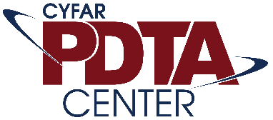
Show Me the Money! Exploring Universities’ Fund Development Policies and Practices
May 6, 2019 at 1:30 p.m. EDT
Presenters:
Autumn Guin and Susan Colby, North Carolina State University
Dorothy Brandon and Ronnie Humphrey II, Alabama A&M University
Kimberly Griffin and Anthony Willey, University of Vermont

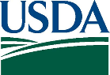
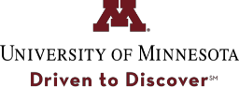
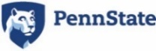
This document was prepared by the Children, Youth, and Families At-Risk (CYFAR) Professional Development and Technical Assistance (PDTA) Center as a resource for CYFAR Sustainable Community Projects (SCP). The CYFAR PDTA Center has been developed in collaboration with the United States Department of Agriculture’s National Institute of Food and Agriculture (USDA-NIFA) through a cooperative agreement with the University of Minnesota and Pennsylvania State University under award number 2018-41520-28908.

What will participants learn from this webinar?
Participants will learn:

- tactics used by current CYFAR Sustainable Community Projects (SCP) grantees to secure financial and in-kind support;
- four strategies for fund development (Share, Ask, Charge, Earn);
- ways to engage their university resource, advancement and development offices in securing project funding; and
- the importance of and tools for communicating impact to potential funders.

What critical findings or research is the basis for the presentation content?
The CYFAR PDTA Center has prepared a sustainability toolkit and this presentation is based on the research that guided its development. Citations for the sustainability toolkit can be provided upon request.

Sustainability studies specific to CYFAR were conducted by Marek, Mancini, Earthman, and Brock.
What are the implications for professionals who work with at-risk children, youth, and families?
The webinar content will empower CYFAR SCP grantees to understand strategies for identifying and approaching potential funders. The webinar content will highlight practical fund-development and relationship-building strategies that have been tested by peers. These strategies can increase CYFAR SCP grantees ability to communication project need and outcomes, foster community ownership, promote cross system collaboration and secure support for project longevity.

Recordings of CYFAR PDTA Center Webinars Will Be Posted Online: https://cyfar.org/resources/webinars

